DAMAN for SME’s
Political Risk Insurance Scheme
Proposal for direct support

1 - Overview and background 2
Addressing contextual risk 2
A scheme which is already operating 2
2 - Context: illegal and illegitimate occupation with long lasting effects 3
In West Bank 3
In East Jerusalem 4
In the Gaza Strip 4
3 - Rationale of the scheme 4
Goals and Objectives 5
Summary of Activities 5
ACAD 5
ASALA 6
4 - Description of the DAMAN Activities 6
5 - Funding 7
Annexes 8
Annex 1 - Means of verification for the claims 8
Annex 2 - The DAMAN Procedures to instruct claims 9
Annex 3 - Stories of clients after ‘Operation Protective Edge’ 10
ACAD Borrowers 10
ASALA Borrowers 12

1 - Overview and background

Addressing contextual risk
DAMAN for SME’s is a non-profit company for the Credit Guarantee Scheme.
DAMAN is a partnership between the Arab Center for Agricultural Development (ACAD) NGO, the Palestinian Business women’s Association (ASALA) NGO, and International Solidarity for Development and Investment (SIDI). New Vision Management Consultancy firm was delegated the responsibility of DAMAN management on behalf of the partners. DAMAN’s scope of activity includes the West Bank, East Jerusalem and Gaza Strip.
The Credit Guarantee Scheme was designed in 2008 to strictly cover political risk which encountered ASALA & ACAD clients in the West Bank and Gaza. New vision has been acting as the Palestinian Credit Guarantee Scheme Centre to monitor and verify claims received by ASALA & ACAD in partnership with SIDI and in an independent manner (see annex of procedures p. 8 and 7).

A scheme which is already operating
New Vision thus received from ASALA on January 22nd, 2013 the first claim that many of their loans were affected by the Israeli war against Gaza which lasted from November 14th to 21st, 2012. As per the agreed procedures, New Vision received a list of documents from ASALA - Gaza office to verify the damage that happened which clarifies the unpaid loans. The supporting documents were from different organizations and municipalities.
New Vision then approved the total amount of unpaid amount of US$ 21’813 only, for a total number of loans 39 loans. The scheme is considered as a relevant instrument, due to the effects of long lasting occupation of Palestine. ASALA was reimbursed by SIDI for the loans taken for projects that were damaged by the war and screened by New Vision.
DAMAN for SME’s is a compensation financial tool for vulnerable persons and groups who undergo directly the effects of strikes, such as women, youth and those residing in areas affected by the separation wall in the West Bank, East Jerusalem and Gaza. DAMAN for SME’s will maintain the political risk scheme initiated in 2008 and expand it to encompass occurrences of damages endured by Palestinians as a result of the Israeli occupation of the Palestinian territories, expanding its outreach and coverage to those residing in East Jerusalem.
Target:
- Micro entrepreneurship, women & men (including farming)
- Producers in all fields of productions as individual borrowers in all areas of Gaza Strip, Jerusalem and West Bank.
- DAMAN will also emphasize supporting the development of micro-enterprises, small businesses, crafts, trades, services which have potential of generating enough profit for the end-user as not to limit his/ her ability to repay the loan.
- Maximum loan amount covered by the scheme is (5000$) five thousand US dollars and maximum coverage of the outstanding balance per one loan is three thousand US dollars (3000$) without the interest.

2 - Context: illegal and illegitimate occupation with long lasting effects
The Israeli occupation of the Palestinian territory since 1967 has had irrevocable consequences on the livelihood of the Palestinian people. The continued expansion of the Israeli state, in the form of illegal settlements, confiscation of land, and other ‘security’ policies such as arrests has a direct impact on the life of the Palestinian people, most evident on the socio-economic front. This is apparent in basic access to food, property, and freedom of movement.

In West Bank
In the case of the West Bank, the annexation of the territory – the wall, constructed in 2002, and deemed illegal by the International Court of Justice, is now 8 meters high and is present in most Palestinian territories that have borders with Israel such as Bethlehem, Qalqilya, parts of Tulkarm and Ramallah and throughout Jerusalem and in many parts the wall has been build inside the Palestinian territories which was occupied in 1967. The wall has acted as a ghettoization tool which continues to isolate residents from basic services and resources impacting the sustainability of communities, the viability and availability of farming land, and overall the existence of an independent Palestinian State. According to the UN Office for the Coordination of Humanitarian Affairs (OCHA) access to agricultural land through the barrier is channeled through (80) gates, majority of which are only open during the olive harvest season and usually for a limited time of the day. Moreover, the agricultural livelihood of over 150 communities in the West Bank has been severely undermined due to access and the loss of land, and damages to greenhouses. Moreover, those dependent on shop owners for their goods now have limited access to goods as the owners themselves are unable to travel due to restrictions, such as curfews, and thus their business is also directly impacted. According to sources, Qalqilya alone lost over 600 shops.

In East Jerusalem
As a result of the annexation, East Jerusalem has also been severely impacted, families have been separated, restrictions due to ID status and permits have exacerbated having a direct impact on the availability of agricultural land, and overall the livelihood of families.

In the Gaza Strip
In the Gaza Strip, the siege imposed on Gazan’s after the coming of the Hamas government in 2007 has had a dire impact on access to education, access to goods, water, and health services. Instability in neighboring Egypt, and issues over border control have resulted in harsher sanctions over the years on Gazan’s causing further economic strains on the people. Over the past 7 years we have witnessed (3) aggressions on Gaza. The most recent aggression, initiated in July 2014 was the most fatal, it lasted a total of (51) days, with a reported 2,147 Palestinians deaths and over 11,000 persons injured. According to the Ministry of Agriculture, the agricultural sector has estimated losses to be $550 million USD. This is almost twice the losses of the 2008-2009 war. Moreover of the 1.8 million inhabitants, the Food and Agriculture Organization estimates that 1.1 million are now dependent on food aid.
Overall, a grave necessity exists to support entrepreneurs, women, and small-farmers in restoring their productive capacity and to assist them in responding to shocks.

3 - Rationale of the scheme
As partners we believe in the economic empowerment of Palestinians as a development tool. Focusing on certain community segments which encounter high unemployment and poverty rates, women, new graduates, people with special needs and other vulnerable person(s) is necessary for the development of communities in Palestine. In order to encourage investment in these areas, we must provide greater guarantees to individuals which serve to protect them from the political related-risks, and support them in providing themselves and their families with a sustainable source of income to meet their basic needs. Furthermore, the on-going targeting of Palestinian civilians and agricultural lands emphasizes the need for practical and safe alternative solutions for the people to cope and overcome the ‘road-blocks’ to their livelihood. The insurance credit guarantee scheme can provide entrepreneurs, women, and young individuals with the opportunity to restore their livelihood and contribute to the economic development of the Palestinian state.

Goals and Objectives
To better serve the clients of ACAD and ASALA in the Palestinian Territories in a context of occupation, i.e.:
- To encourage investment in areas affected highly by the occupation
- Improve living conditions
- Job-creation
- Insure vulnerable clients

Summary of Activities

ACAD
Based in Ramallah, ACAD over the years has expanded to cover the entire West Bank and Gaza Strip and has managed to evolve from a purely agricultural institution to a diversified micro credit company. In 2014, ACAD Finance, a regulated specialized lending institution was created. ACAD Finance is a shareholding company; the Arab Center for Agricultural development holds the largest share, with 4 international investors, SIDI, Grameen-Credit-Agricole, EIB, and Triple Jump. ACAD the NGO is the intended partner in DAMAN for SME’s.
ACAD launched activities in Gaza in 1995. From 1995, and as of July 2014, ACAD disbursed loans in amount of 37, 127, 567 USD financing projects targeting poor women and low income families. Total number of loans disbursed is 15,550. Up to 01/07/2014 before the Gaza war, the portfolio of Gaza was $888,072 that is 19% of ACAD’s gross portfolio.
After the cease fire the ACAD team began communications with the beneficiaries and found that:
- More than 15% of ACAD’s clients have injured members of the family
- All livestock and agriculture projects were damaged
- 74 clients completely or partially lost their projects (the balance of loans $173,899 USD)
- The majority of ACAD Gaza clients are impoverished individuals with small businesses; this resulted in them spending their money during the war time by reducing their projects capital without any alternative source of income.
- All clothing and retail projects suffered the loss of their high season sales (summer and Eid’ Holiday)
- Portfolio at Risk (PAR) > 31 days reached 70% on 30-9-2014

ASALA
ASALA, the Palestinian Business women’s Association was established in 1997. ASALA’s headquarter is in Ramallah and it has (10) offices and branches in the West Bank and Gaza Strip. ASALA targets impoverished and excluded Palestinian women in order to empower them and put them on a track that will lead to financial independence and stability. ASALA In 2014 established a profit micro credit company – ASALA for Credit and Development. ASALA the NGO is the intended partner in DAMAN for SME’s.
ASALA found after 2014 aggression on Gaza that its client’s projects claimed losses due to total project damage in sum of $ 1,562,900 USD, and projects which were partially damaged, clients claimed a loss of $815,970 USD. As for the claims for homes totally damaged as a result of bombings and the Israeli attack the sum is $8,445,500 USD. For partial damage of homes clients claimed $1,835,880 USD.

4 - Description of the DAMAN Activities
DAMAN for SME’s seeks to provide insurance coverage for highly vulnerable borrowers of ACAD and ASALA. Coverage will be only in the form of paying the loan outstanding balance to ACAD and ASALA on behalf of the borrower.
The following is the claim eligibility criteria:
- Borrowers who are impacted due to restrictions on exports to Israel or abroad
- Borrower and /or first degree relative has been killed by Israeli army.
- Project initiated by the entrepreneur destroyed totally or partially by Israeli occupation
- Entrepreneurs jailed for political reasons (more than 2 months)
- Long term curfew (occurring after loan extension) affecting production process for a long period or affected the sale of the product(s)
- Confiscation of land related to the project

5 - Funding
                - DAMAN will develop a promotion strategy to raise funds as non-profit company to support the Palestinian development from different donors and agencies and civil societies in different countries.
All partners are eager to make sure that DAMAN avails of the necessary capital so as to possibly compensate the victimized clients of ACAD and ASALA.
SIDI is presently availing of a guarantee capacity of 100’000 Euros (One hundred thousand Euros) in as guarantee collaterals, to make DAMAN a reality.
The expected amount that DAMAN is raising to support ASALA and ACAD is presently 300’000 US$ so as to possibly compensate the identified damage.
Given the present structural status of occupation with its violent outcomes, the instrument is targeting to reach 5 M US$.

Annexes

Annex 1 - Means of verification for the claims
The following are means of verification for the claims developed by New Vision.
1- Death of the client or one of his/her sons by Israeli actions
  - Death certificate from the Ministry of Health
  - Certificate from the Martyrs Association

2- Arrest of the client by Israeli Soldiers
- Certificate from the Red Cross
- Certificate from the Village/city council that the client was arrested

3- Israeli soldiers destroyed the agricultural land
- Certificate from the Village/city council that the client agricultural land was destroyed by Israeli soldiers
- Certificate from the Village/city agricultural department that the client agricultural land was destroyed by Israeli soldiers
- Pictures documenting the incident

4- Israeli soldiers destroyed the client project
- Certificate from the Village/city council that the client project was destroyed by Israeli soldiers
- Certificate from the Village/city youth club/women association that the client project was destroyed by Israeli soldiers
- Pictures documenting the incident

5- Israeli Curfew on the village /city
- Certificate from the Red Cross for the duration of the curfew
- Certificate from the Village/city council that the client project location was under curfew.
- Certificate from the Village/city chamber of commerce that the client project location was under curfew.

6- Israeli block the products and goods movement
- Certificate from the Village/city council that the client type of products was under siege and Israeli didn’t allow free movement of products and goods from that area.
- Certificate from the Village/city chamber of commerce that the client type of products was under siege and Israeli didn’t allow free movement of products and goods from that area.

The clients have to support his/her claim with all the requested documents for each case explained above.

Annex 2 - The DAMAN Procedures to instruct claims
Stage | Description
1 | Loan Application: Clients apply to ACAD/ASALA for loans
2 | Decision by ACAD/ASALA: approval of the loan by ACAD/ASALA at credit committee (weekly).
3 | Notification: ACAD/ASALA presents to DAMAN the portfolio to be covered
4 | Receipt by GUARANTEE SCREEN COMPANY (NEW VISION): The list is signed by the GUARANTEE SCREEN COMPANY (NEW VISION) (acknowledgement of receipt) (two copies, 1 with ACAD/ASALA). The items in the list: loan N°, name, location, project type, amount approved, duration, social status, collateral collected, date of application + date of approval by ACAD/ASALA, a sentence of comment.  A summary of the amount requested
5 | Decision by the GUARANTEE SCREEN COMPANY (NEW VISION): one week to turn down/amend the proposal to cover the risk. The decision is notified by the GUARANTEE SCREEN COMPANY (NEW VISION). Silence means approval.
6 | Checking data: During the time frame of 1 week the GUARANTEE SCREEN COMPANY (NEW VISION) is entitled to check, a sample of or all file to investigate the quality of the list, (“DAMAN portfolio” only and is clearly identified (in the MIS). The related cost for checking is covered by the GUARANTEE SCREEN COMPANY (NEW VISION).
7 | Extending loans: ACAD/ASALA extends loans
8 | Addressing arrears: In case of arrears, ACAD/ASALA enforces its usual recovery policy and practices, ACAD/ASALA can claim 90 days after due payment, showing that ACAD/ASALA started the process of enforcement of the other securities (i.e. promissory note transferred to the lawyer, contract payment (after two visits by ACAD/ASALA’s staff) and cashing postponed checks stamp from the bank).
9 | Special circumstances for claim, eligibility criteria:  - Proven decrease of the purchasing power generated by the stopping by Israel of tax revenues, the financial boycott to the PNA  - Restricted exports (despite a signed contract with Israel clients)  - Project initiated by the entrepreneur destroyed with proofs,  - Entrepreneurs jailed for political reason (more than 2 months);  - Entrepreneurs or one of his/her family member was killed as a result of the political conflict.  - Long term curfew (occurring after loan extension) or close of the area with obvious effects on economical. If the production process is stopped for a long period (as a result of the closure) or the product cannot be sold for closing market (especially for agricultural project).  - Confiscation of land related to the project.
10 | Claiming:  1. ACAD/ASALA will send every 3 months a detailed list with all client data and the remaining balance to be settled and the overall amount to claim. The GUARANTEE SCREEN COMPANY (NEW VISION) has 1 month to review the list. During this month, the GUARANTEE SCREEN COMPANY (NEW VISION) is entitled to do any further investigation regarding the good faith of the list.  2. After one month ACAD/ASALA is allowed to claim the related amount to the Trust through its Secretary. A copy of the claim will go to the GUARANTEE SCREEN COMPANY (NEW VISION).  3. The GUARANTEE SCREEN COMPANY (NEW VISION) sends an immediate report stating its approval/ refusal of the list. In case of refusal or discrepancy, the GUARANTEE SCREEN COMPANY - (NEW VISION) has 1 additional week to make to issue a counter report.  4. The approved amount is disbursed at once by the Trust.  5. The “disagreed amount” will be discussed again between ACAD/ASALA, the GUARANTEE SCREEN COMPANY (NEW VISION) and the Secretary to settle the matter. In case of further discrepancies, the final decision lies in the Secretary hands.

Annex 3 - Stories of clients after ‘Operation Protective Edge’

ACAD Borrowers
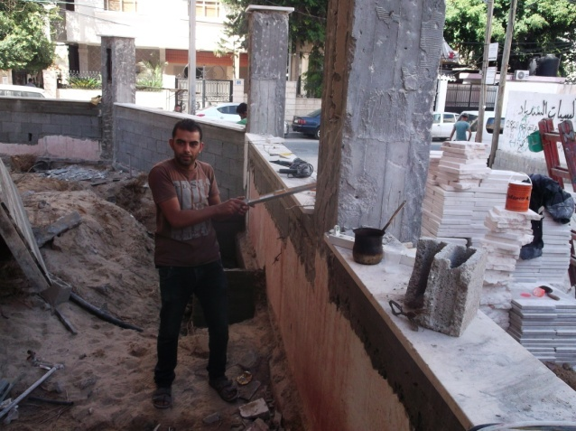
Borrower Name: Husni Mohammad Hasan Sukar.
Mr.Sukar (after)
Mr.Sukar (before)
Loan Number: 000153/13/05
Family: 8 children
Mr. Sukar is a building contractor, he was granted a loan in amount of 7,000$ in 2013 for buying timber for construction. The project was located in Al-Shajaia neighborhood Alnazzaz Street, which is the same location of the borrower’s home place (a building of four levels containing the borrower’s house and his project). This location was exposed to the worst types of the Israeli aggression in the last war. On 22/07/2014, this neighborhood -without any warning- was unprecedentedly violently destroyed with all kinds of fighter jets, from aircrafts and tanks to highly explosive and destructive weapons of war.
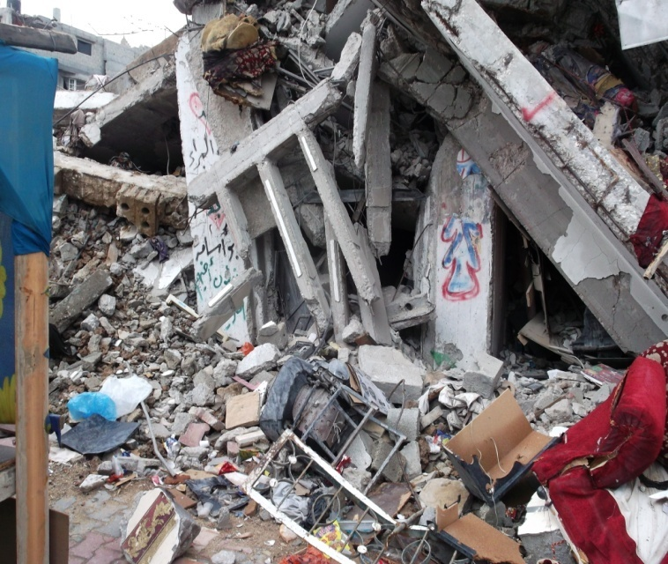
Residents fled from that district to another where they sought shelter in UNRWA schools. Unfortunately, the borrower’s house was directly targeted by the F16 aircrafts with several Israeli bombs, resulting in the destruction of the entire building. Most of the borrower’s family members succeeded in evacuating the house minutes before its destruction. Unfortunately, his eldest son couldn’t make it, After losing his house, the borrower and his family were displaced to one of the UNRWA’s schools. The borrower wanted to search for his son; he wanted to know if he was injured or martyred, but he couldn’t because the neighborhood was like a fire torch. He tried to coordinate with the Red Cross to reach his boy, but he waited several days without any response from the Israeli Occupation military forces. After 14 days, he dragged his sons’ corpse from under the house ruins, and buried his remains during a 12 hour truce. An extreme tragic scene for Mr. Sukar during this aggression was the corpse of a Palestinian with decomposed unidentified features under his home ruins.

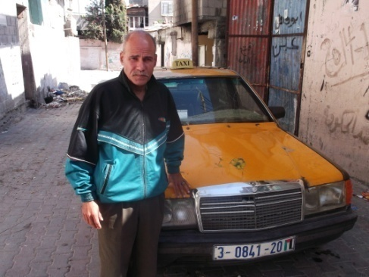
Borrower Name: Jamal Motawe’ Ghoubon.
Mr.Jamal (before)
Family :8 children.
Loan Number: 05/13/000124
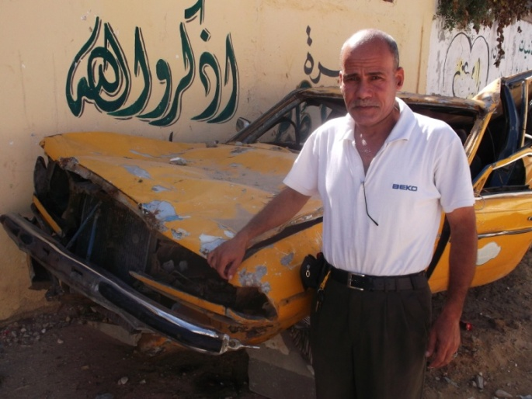
Jamal is a taxi driver, he was granted a loan in amount of 5,000$ in 2013 to purchase a taxi. Jamal lived in Al-Bureij refugee camp in the Eastern region of the Gaza Strip. Unfortunately, his house was directly targeted by the F16 aircrafts with highly explosive missiles, in which his home was completely destroyed. Five minutes before the house was bombed, Jamal’s family was warned by missile’ drones ‘warning to vacate their home; quickly they vacated their home without taking anything (including the refinanced taxi), and fled to one of the UNRWA’s schools. The family stayed at the UNRWA school for more than one month even after the ceasefire.

Mr. Jamal (after) with his destroyed car

ASALA Borrowers
